SIT123: Data Capture Technologies

# Lab Report Week 7: Data Visualization

In this task, we will design and develop visualizations for sensor data.

## 

## Pre-requisites: You must do the following before this task

1. **Attend Class (Lecture)**
2. **What following resources and videos on introduction to Tableau and how to build basic visualizations** (you might need to provide your details to be able to watch the videos)

<https://www.tableau.com/learn/tutorials/on-demand/tableau-interface>

<https://onlinehelp.tableau.com/current/guides/get-started-tutorial/en-us/get-started-tutorial-connect.html>

<https://www.tableau.com/learn/tutorials/on-demand/getting-started>

[https://www.analyticsvidhya.com/blog/2017/07/data-visualization-made-easy/](https://www.analyticsvidhya.com/blog/2017/07/data-visualisation-made-easy/)

1. **Read this sheet from top to bottom**

## Task Objective

**This is an individual task.** You will need to design and develop a visualization for the sensor data shared here:

<https://drive.google.com/file/d/1ResskTdqMN2Md770ICK99ehIWURBSsgz/view?usp=sharing>

<https://drive.google.com/file/d/1m8uRS9a7UOJrQn2mfCD_XYbF5AJo6JZH/view?usp=sharing>

## Software Required

* Tableau - Available in the lab

## Task Submission Details

The Lab work in this week is continuation from last week (Lab work in week 6). Answer the following questions in this word document itself and submit to unit site.

### **Q1. Use the visualization in Q3 of Week 6’s Lab work to provide some insights to the sensor data. Provide the discussion below.**

As time went on from the beginning of the duration of capture time, the time that the temperature remained the same as the temperature itself dropped increased. The temperature also decreased non-linearly.

### **Q2. Use your visualization knowledge to critique the given visualization below. Consider the following in your critique:**

* Who is the audience? (expert? non-expert?)
* What questions does this visualization answer?
* What design principles best describe why it is good / bad?
* Why do you like / dislike this visualization?
* Can you suggest any improvements?

#### Cattle herd – population changes in Australia

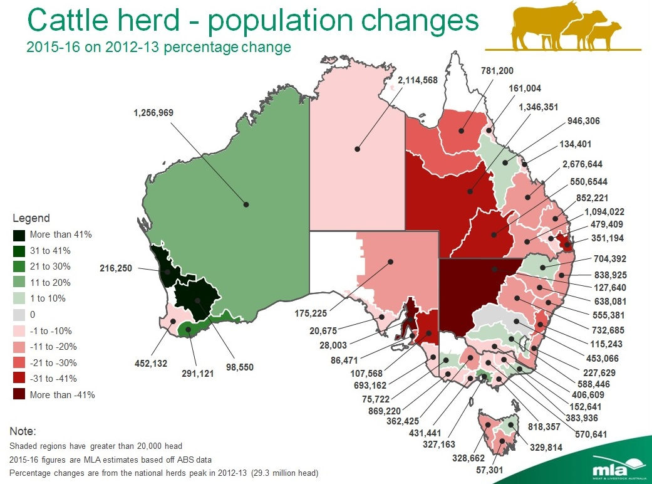

**Your Critique:**

This infographic is for non-experts who wish to know the change in the number of cattle in each region highlighted in Australia. A good aspect of the design is that there is a key that represents how much the population of cattle has changed. Each region corresponds with a colour that represents the percentage of change. A bad aspect is that particularly in the east side of Australia, there are so many regions that it makes the infographic look cluttered. A way to fix this would be to have an infographic for each state rather than for the entirety of Australia.

#### b) World’s Top 10 Greenhouse Gas Emitters, and How They’ve Changed

<http://www.wri.org/blog/2017/04/interactive-chart-explains-worlds-top-10-emitters-and-how-theyve-changed>

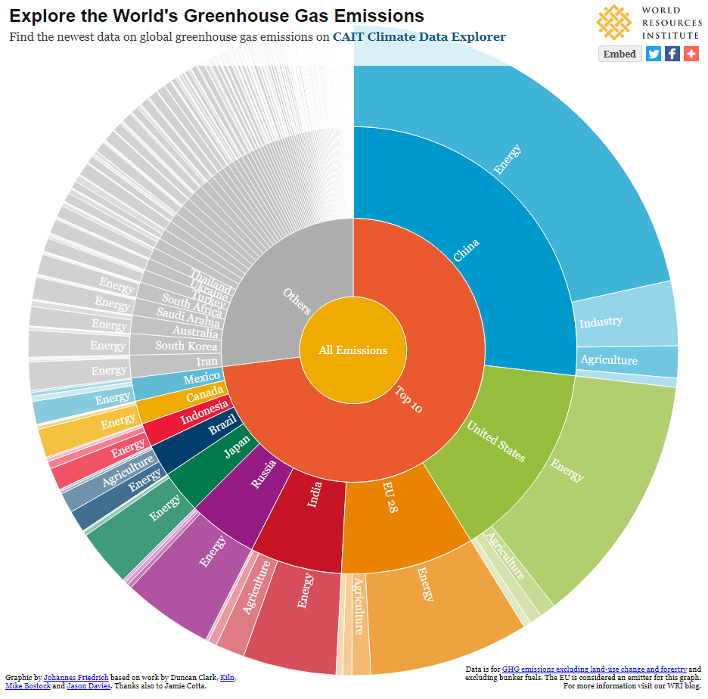

**Your Critique:**

This Infographic shows how much greenhouse gas emissions different categories such as countries and industries produce. It presents different categories of data effectively and simultaneously. However, where the graph falls short is with areas that produce a miniscule amount of greenhouse gas emissions. These areas can barely be seen or not seen at all as it is too dense. The graph could also benefit from having the percentages displayed as this graph does not really specify an exact amount for each area. This makes the differences between two areas that are similar in amounts of emissions unclear.

### **Q3: visit the website** [**https://covid-19-au.com/**](https://covid-19-au.com/) **and critique the map on how easy and quick it was to find the total, active and recovered cases in your area (suburb)?**

To find the total, active and recovered number of cases in my area, I first had to find my suburb on the map. I could use the dropdown menu at the top-left corner of the map to switch between which statistic I wanted to view. This was ok, my only issue was that it took me awhile to find my suburb amongst the many other suburbs surrounding mine. This map could benefit from a search bar that one can type their suburb into and have its statistics shown. This would make extracting the information one is looking for more easy and rapid.

